Figure 1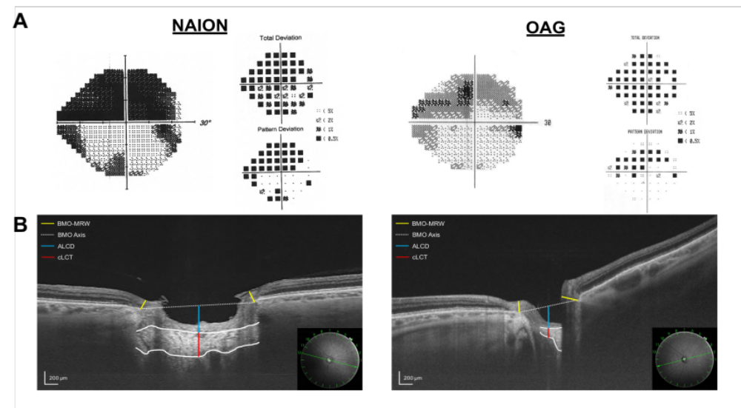
A: example of an NAION eye (left) and OAG eye (right) matched for age, 24-2 mean deviation, and pattern and location of visual loss. B: radial B-scans with schematic representations of optic nerve head measurements.

Figure 2
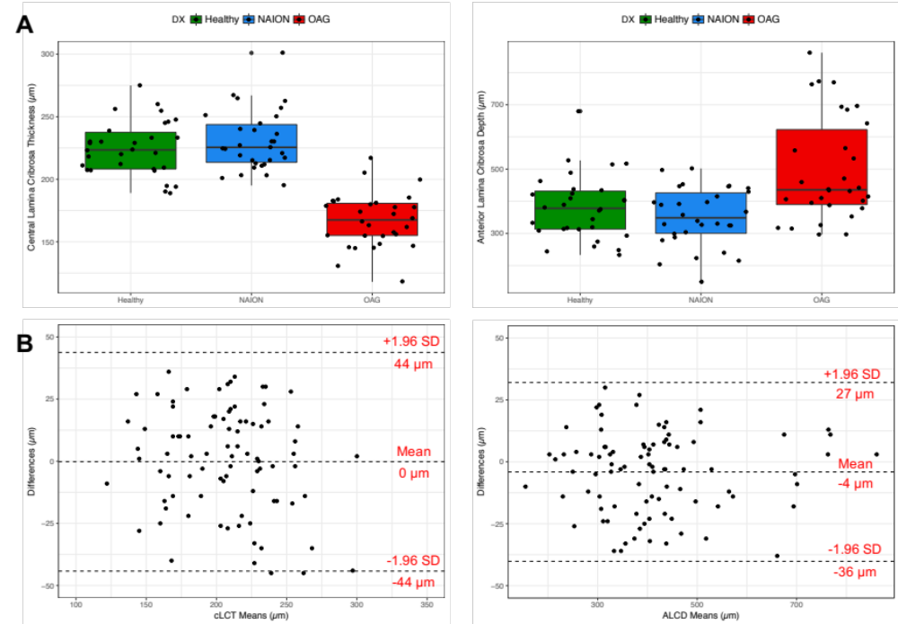
A: box and jitter plots comparing distributions of cLCT (left) and ALCD (right) between the three groups. B: Bland-Altman limits of agreement for cLCT (left) and ALCD (right) measurements.

Figure 3
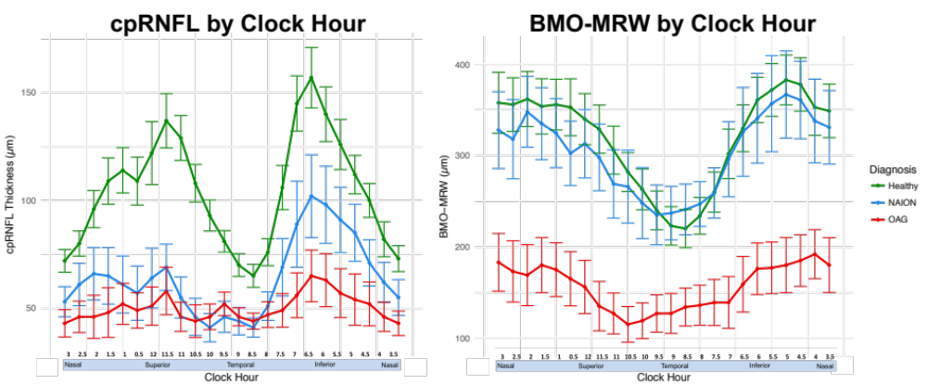
Comparisons of cpRNFL thickness and BMO-MRW between groups, presented in NSTIN format. Error bars are ± 2 standard errors.

Figure 4
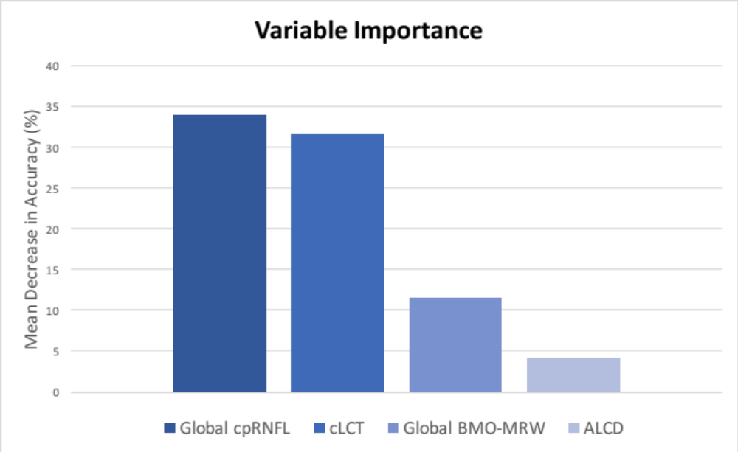
A comparison of the relative importance of each variable in a 4 variable Random Forest model.

Table 1
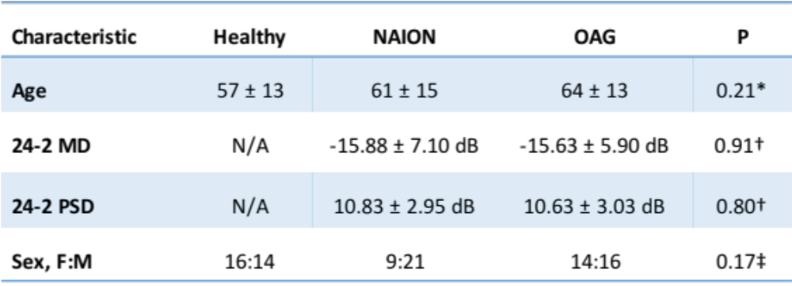
* Result of ANOVA between groups. † T-test comparison of NAION and OAG means. ‡ Result of χ² test of independence. Data are mean ± standard deviation. Healthy controls did not receive 24-2 visual field tests.

Table 2
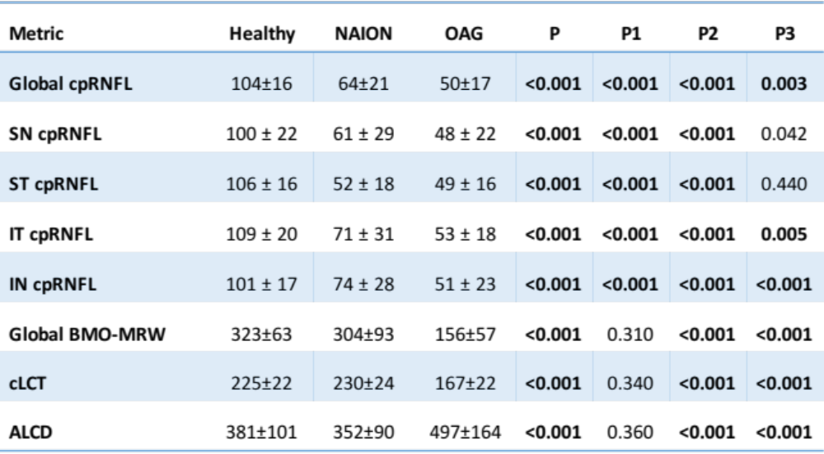
Data are mean ± standard deviation. P, comparison of three groups using ANOVA; P1, comparison of Healthy vs NAION; P2, comparison of Healthy and OAG; P3, comparison of Healthy and NAION. P-values significant after Bonferroni correction for multiple comparisons (P<0.006) are in boldface.

Table 3
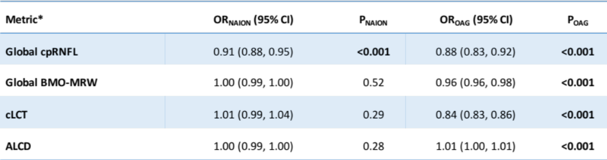
OR_{NAION} and OR_{OAG} are odds ratio results from a multinomial logistic regression for NAION and OAG classification, respectively, with healthy controls as the reference class. P values significant at the 5% level are in boldface. *All tests are adjusted for age.

Table 4
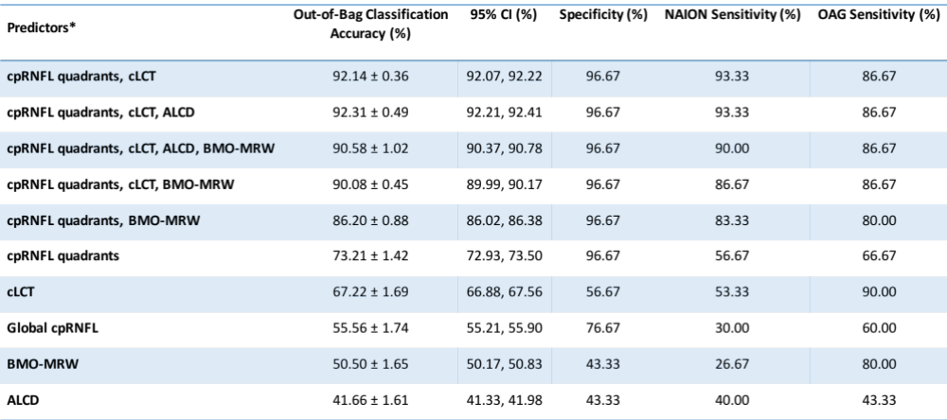
Out-of-bag prediction accuracy of Random Forest models, mean ± standard deviation. *All prediction models are adjusted for age.

